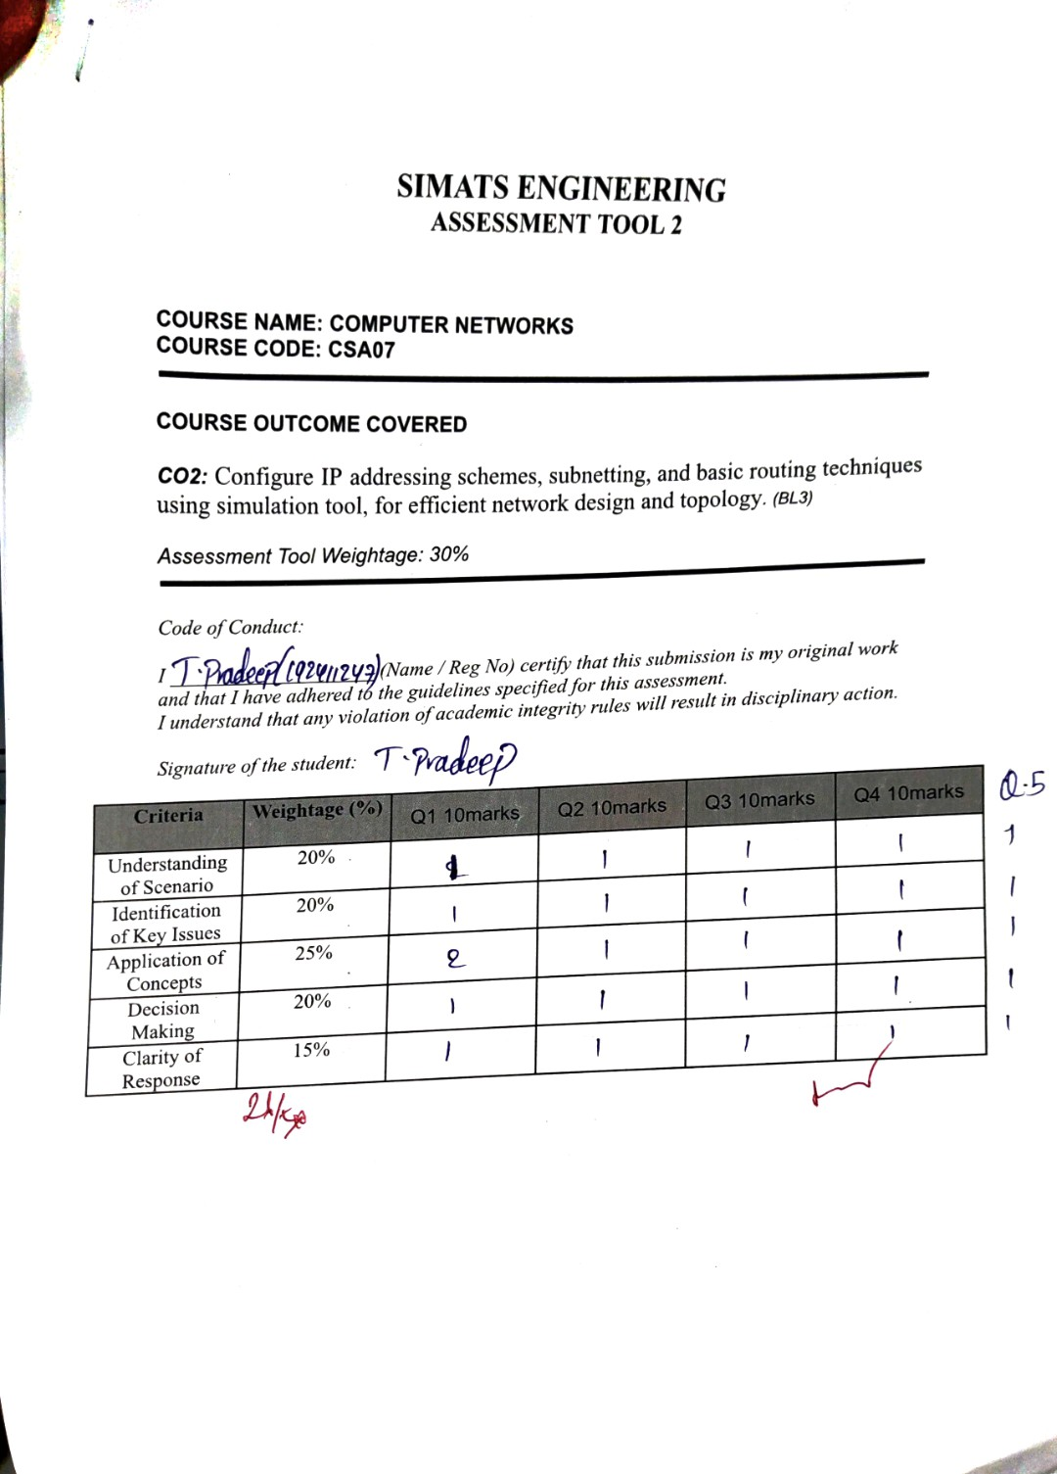

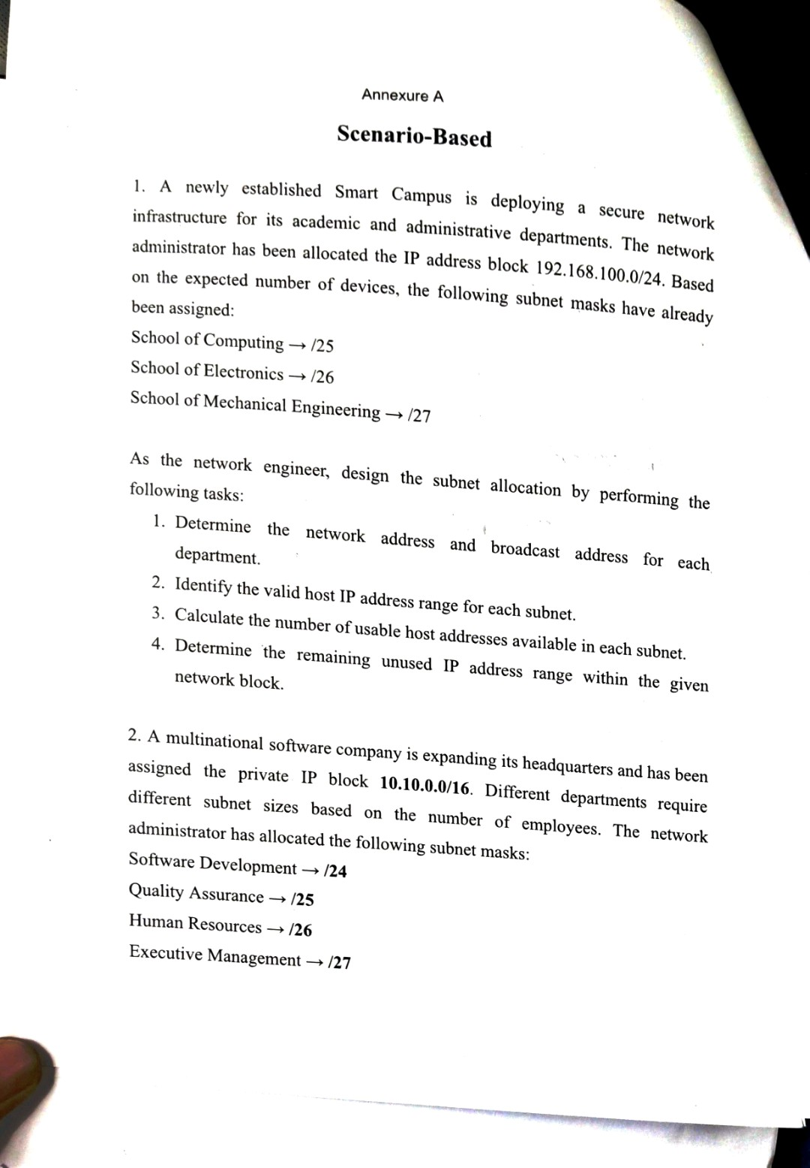

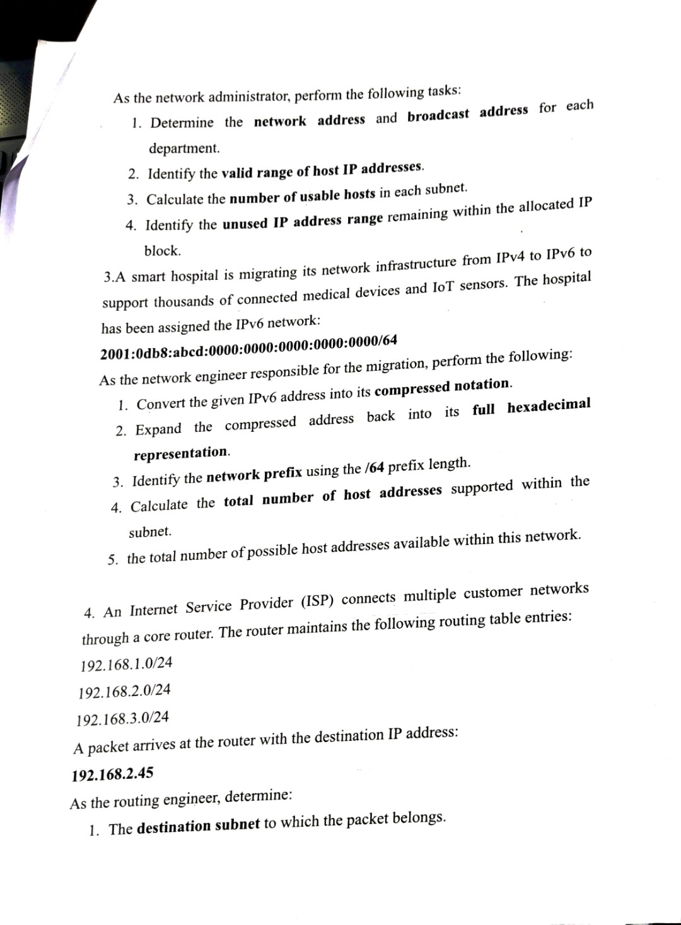

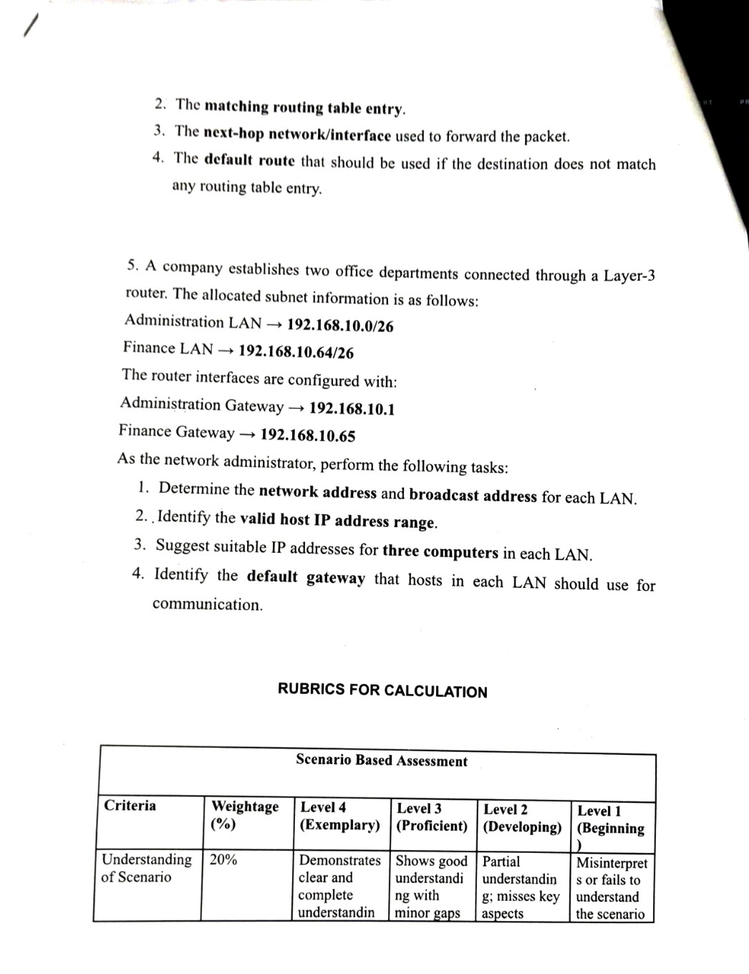

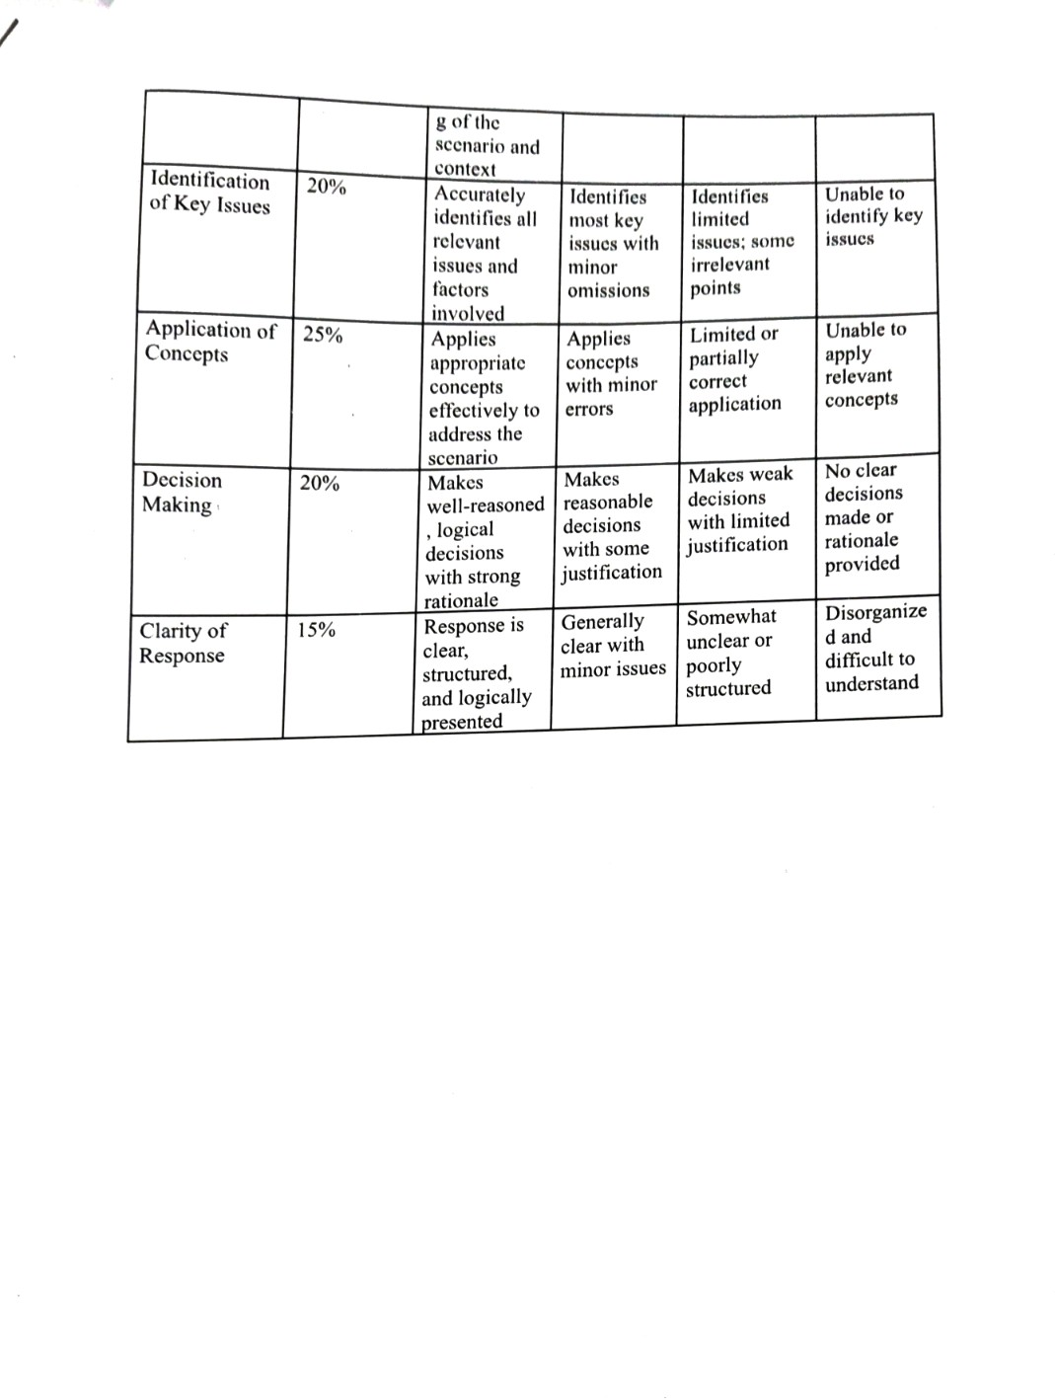
SIMATS ENGINEERING
ASSESSMENT TOOL 2

COURSE NAME: COMPUTER NETWORKS
COURSE CODE: CSA07

COURSE OUTCOME COVERED

CO2: Configure IP addressing schemes, subnetting, and basic routing techniques using simulation tool, for efficient network design and topology. (BL3)

Assessment Tool Weightage: 30%

Code of Conduct:

I ___T. Pradeep(192411247)_ (Name / Reg No) certify that this submission is my original work and that I have adhered to the guidelines specified for this assessment.
I understand that any violation of academic integrity rules will result in disciplinary action.

Signature of the student: T. Pradeep

Criteria | Weightage (%) | Q1 10marks | Q2 10marks | Q3 10marks | Q4 10marks
Understanding of Scenario | 20%
Identification of Key Issues | 20%
Application of Concepts | 25%
Decision Making | 20%
Clarity of Response | 15%

Annexure A

Scenario-Based

1. A newly established Smart Campus is deploying a secure network infrastructure for its academic and administrative departments. The network administrator has been allocated the IP address block 192.168.100.0/24. Based on the expected number of devices, the following subnet masks have already been assigned:
School of Computing → /25
School of Electronics → /26
School of Mechanical Engineering → /27

As the network engineer, design the subnet allocation by performing the following tasks:
- Determine the network address and broadcast address for each department.
- Identify the valid host IP address range for each subnet.
- Calculate the number of usable host addresses available in each subnet.
- Determine the remaining unused IP address range within the given network block.

Answer:
Given: IP block 192.168.100.0/24 (256 addresses); School of Computing = /25, School of Electronics = /26, School of Mechanical Engineering = /27. Block size = 2^(32 − prefix); the subnets are placed one after another, largest first, so they do not overlap.
1. Determine the network address and broadcast address for each department.
School of Computing (/25, mask 255.255.255.128): block size = 2^7 = 128. Network address = 192.168.100.0; broadcast = 0 + 128 − 1 = 127 → 192.168.100.127.
School of Electronics (/26, mask 255.255.255.192): block size = 2^6 = 64. It starts at 127 + 1 = 128, so network address = 192.168.100.128; broadcast = 128 + 64 − 1 = 191 → 192.168.100.191.
School of Mechanical Engineering (/27, mask 255.255.255.224): block size = 2^5 = 32. It starts at 191 + 1 = 192, so network address = 192.168.100.192; broadcast = 192 + 32 − 1 = 223 → 192.168.100.223.
Department | Network address | Broadcast address
Computing (/25) | 192.168.100.0 | 192.168.100.127
Electronics (/26) | 192.168.100.128 | 192.168.100.191
Mechanical (/27) | 192.168.100.192 | 192.168.100.223

2. Identify the valid host IP address range for each subnet.
Valid hosts = network address + 1 to broadcast address − 1.
Computing: 192.168.100.1 – 192.168.100.126.
Electronics: 192.168.100.129 – 192.168.100.190.
Mechanical Engineering: 192.168.100.193 – 192.168.100.222.
3. Calculate the number of usable host addresses available in each subnet.
Usable hosts = 2^(host bits) − 2.
Computing: 2^7 − 2 = 128 − 2 = 126.
Electronics: 2^6 − 2 = 64 − 2 = 62.
Mechanical Engineering: 2^5 − 2 = 32 − 2 = 30.
4. Determine the remaining unused IP address range within the given network block.
Addresses used = 128 + 64 + 32 = 224 (192.168.100.0 – 192.168.100.223).
Unused range = 192.168.100.224 – 192.168.100.255, i.e. 256 − 224 = 32 addresses (the block 192.168.100.224/27).
Summary
Department | Network | Valid host range | Broadcast | Usable hosts
Computing (/25) | 192.168.100.0 | 192.168.100.1 – .126 | 192.168.100.127 | 126
Electronics (/26) | 192.168.100.128 | 192.168.100.129 – .190 | 192.168.100.191 | 62
Mechanical (/27) | 192.168.100.192 | 192.168.100.193 – .222 | 192.168.100.223 | 30

Unused range: 192.168.100.224 – 192.168.100.255 (32 addresses).

2. A multinational software company is expanding its headquarters and has been assigned the private IP block 10.10.0.0/16. Different departments require different subnet sizes based on the number of employees. The network administrator has allocated the following subnet masks:
Software Development → /24
Quality Assurance → /25
Human Resources → /26
Executive Management → /27
As the network administrator, perform the following tasks:
- Determine the network address and broadcast address for each department.
- Identify the valid range of host IP addresses.
- Calculate the number of usable hosts in each subnet.
- Identify the unused IP address range remaining within the allocated IP block.
Answer:
Given: IP block 10.10.0.0/16 (65,536 addresses); Software Development = /24, Quality Assurance = /25, Human Resources = /26, Executive Management = /27. Subnets are allocated from largest to smallest, each starting where the previous one ends.
1. Determine the network address and broadcast address for each department.
Software Development (/24, mask 255.255.255.0): block size 2^8 = 256. Network address = 10.10.0.0; broadcast = 10.10.0.255.
Quality Assurance (/25, mask 255.255.255.128): block size 128. It starts at 10.10.1.0; broadcast = 0 + 128 − 1 = 127 → 10.10.1.127.
Human Resources (/26, mask 255.255.255.192): block size 64. It starts at 10.10.1.128; broadcast = 128 + 64 − 1 = 191 → 10.10.1.191.
Executive Management (/27, mask 255.255.255.224): block size 32. It starts at 10.10.1.192; broadcast = 192 + 32 − 1 = 223 → 10.10.1.223.
Department | Network address | Broadcast address
Software Development (/24) | 10.10.0.0 | 10.10.0.255
Quality Assurance (/25) | 10.10.1.0 | 10.10.1.127
Human Resources (/26) | 10.10.1.128 | 10.10.1.191
Executive Management (/27) | 10.10.1.192 | 10.10.1.223

2. Identify the valid range of host IP addresses.
Valid hosts = network address + 1 to broadcast address − 1.
Software Development: 10.10.0.1 – 10.10.0.254.
Quality Assurance: 10.10.1.1 – 10.10.1.126.
Human Resources: 10.10.1.129 – 10.10.1.190.
Executive Management: 10.10.1.193 – 10.10.1.222.
3. Calculate the number of usable hosts in each subnet.
Usable hosts = 2^(host bits) − 2.
Software Development: 2^8 − 2 = 254.
Quality Assurance: 2^7 − 2 = 126.
Human Resources: 2^6 − 2 = 62.
Executive Management: 2^5 − 2 = 30.
4. Identify the unused IP address range remaining within the allocated IP block.
Addresses used = 256 + 128 + 64 + 32 = 480 (10.10.0.0 – 10.10.1.223).
Unused range = 10.10.1.224 – 10.10.255.255, i.e. 65,536 − 480 = 65,056 addresses.
Summary
Department | Network | Valid host range | Broadcast | Usable hosts
Software Dev (/24) | 10.10.0.0 | 10.10.0.1 – .254 | 10.10.0.255 | 254
QA (/25) | 10.10.1.0 | 10.10.1.1 – .126 | 10.10.1.127 | 126
HR (/26) | 10.10.1.128 | 10.10.1.129 – .190 | 10.10.1.191 | 62
Exec Mgmt (/27) | 10.10.1.192 | 10.10.1.193 – .222 | 10.10.1.223 | 30

Unused range: 10.10.1.224 – 10.10.255.255 (65,056 addresses).

3.A smart hospital is migrating its network infrastructure from IPv4 to IPv6 to support thousands of connected medical devices and IoT sensors. The hospital has been assigned the IPv6 network:
2001:0db8:abcd:0000:0000:0000:0000:0000/64
As the network engineer responsible for the migration, perform the following:
- Convert the given IPv6 address into its compressed notation.
- Expand the compressed address back into its full hexadecimal representation.
- Identify the network prefix using the /64 prefix length.
- Calculate the total number of host addresses supported within the subnet.
- the total number of possible host addresses available within this network.

Answer:
Given: IPv6 network 2001:0db8:abcd:0000:0000:0000:0000:0000/64. An IPv6 address has 128 bits = 8 groups of 16 bits; the /64 prefix is the first 4 groups and the last 4 groups are the host (interface) ID.
1. Convert the given IPv6 address into its compressed notation.
Split into groups: 2001 | 0db8 | abcd | 0000 | 0000 | 0000 | 0000 | 0000.
Remove leading zeros: 0db8 → db8; each 0000 → 0 → 2001:db8:abcd:0:0:0:0:0.
Groups 4 to 8 (five groups) are all zero, so replace them with "::" (allowed only once).
Compressed notation: 2001:db8:abcd::/64.
2. Expand the compressed address back into its full hexadecimal representation.
2001:db8:abcd:: has 3 written groups (2001, db8, abcd), so "::" represents 8 − 3 = 5 zero groups.
Insert them: 2001:db8:abcd:0:0:0:0:0, then pad every group to 4 hex digits.
Full form: 2001:0db8:abcd:0000:0000:0000:0000:0000/64 (the original address).
3. Identify the network prefix using the /64 prefix length.
64 bits = 4 groups, so the prefix is the first four groups: 2001:0db8:abcd:0000.
Network prefix = 2001:db8:abcd:0::/64, written in short form as 2001:db8:abcd::/64.
The host portion (interface ID) is the last four groups: 0000:0000:0000:0000.
4. Calculate the total number of host addresses supported within the subnet.
Host bits = 128 − 64 = 64.
Total addresses = 2^64 = 18,446,744,073,709,551,616 (about 1.8 × 10^19).
Address range: 2001:db8:abcd:0:0:0:0:0 to 2001:db8:abcd:0:ffff:ffff:ffff:ffff.
5. The total number of possible host addresses available within this network.
This bullet repeats the previous task: the network 2001:db8:abcd::/64 provides 2^64 = 18,446,744,073,709,551,616 possible host addresses.
IPv6 has no broadcast address, so the "− 2" used in IPv4 is not applied (the all-zeros interface ID is reserved as the subnet-router anycast address).
Summary
Item | Result
Compressed notation | 2001:db8:abcd::/64
Full (expanded) form | 2001:0db8:abcd:0000:0000:0000:0000:0000/64
Network prefix | 2001:db8:abcd::/64
Total host addresses | 2^64 = 18,446,744,073,709,551,616

4. An Internet Service Provider (ISP) connects multiple customer networks through a core router. The router maintains the following routing table entries:
192.168.1.0/24
192.168.2.0/24
192.168.3.0/24
A packet arrives at the router with the destination IP address:
192.168.2.45
As the routing engineer, determine:
- The destination subnet to which the packet belongs.
- The matching routing table entry.
- The next-hop network/interface used to forward the packet.
- The default route that should be used if the destination does not match any routing table entry.
Answer:
Given: Routing table entries 192.168.1.0/24, 192.168.2.0/24 and 192.168.3.0/24. Destination IP of the packet = 192.168.2.45. The router compares the destination with each entry using the entry's mask (longest prefix match).
1. The destination subnet to which the packet belongs.
All entries are /24 = 255.255.255.0, so only the first three octets are compared.
192.168.2.45 AND 255.255.255.0 = 192.168.2.0.
The destination subnet is 192.168.2.0/24 (addresses 192.168.2.0 – 192.168.2.255, valid hosts 192.168.2.1 – 192.168.2.254, broadcast 192.168.2.255). 192.168.2.45 is a valid host in it.
2. The matching routing table entry.
192.168.1.0/24: network 192.168.1.0 ≠ 192.168.2.0 → no match.
192.168.2.0/24: network 192.168.2.0 = 192.168.2.0 → match.
192.168.3.0/24: network 192.168.3.0 ≠ 192.168.2.0 → no match.
Matching entry = 192.168.2.0/24 (the only match, so it is also the longest-prefix match).
3. The next-hop network/interface used to forward the packet.
The packet is forwarded using the 192.168.2.0/24 entry, i.e. out of the router interface (or to the next-hop router) that leads to the 192.168.2.0/24 customer network.
The table does not list next-hop addresses; if the network is directly connected, the router sends the packet out of its interface in 192.168.2.0/24 (for example 192.168.2.1) and delivers it to host 192.168.2.45 using ARP.
4. The default route that should be used if the destination does not match any routing table entry.
The default route is 0.0.0.0/0 (mask 0.0.0.0), which matches every address with the shortest possible prefix.
Such packets are sent to the ISP's upstream next-hop router (gateway of last resort) instead of being dropped.
Summary
Item | Result
Destination subnet | 192.168.2.0/24
Matching routing entry | 192.168.2.0/24
Next hop / interface | Interface or next-hop router connected to 192.168.2.0/24
Default route | 0.0.0.0/0 via the upstream ISP gateway

5. A company establishes two office departments connected through a Layer-3 router. The allocated subnet information is as follows:
Administration LAN → 192.168.10.0/26
Finance LAN → 192.168.10.64/26
The router interfaces are configured with:
Administration Gateway → 192.168.10.1
Finance Gateway → 192.168.10.65
As the network administrator, perform the following tasks:
- Determine the network address and broadcast address for each LAN.
- Identify the valid host IP address range.
- Suggest suitable IP addresses for three computers in each LAN.
- Identify the default gateway that hosts in each LAN should use for communication.
Answer:
Given: Administration LAN = 192.168.10.0/26 (gateway 192.168.10.1); Finance LAN = 192.168.10.64/26 (gateway 192.168.10.65); the LANs are connected by a Layer-3 router. /26 → mask 255.255.255.192, block size 2^6 = 64, usable hosts = 64 − 2 = 62.
1. Determine the network address and broadcast address for each LAN.
Administration LAN: network address = 192.168.10.0; broadcast = 0 + 64 − 1 = 63 → 192.168.10.63.
Finance LAN: network address = 192.168.10.64; broadcast = 64 + 64 − 1 = 127 → 192.168.10.127.
2. Identify the valid host IP address range.
Valid hosts = network address + 1 to broadcast address − 1.
Administration LAN: 192.168.10.1 – 192.168.10.62 (62 hosts).
Finance LAN: 192.168.10.65 – 192.168.10.126 (62 hosts).
3. Suggest suitable IP addresses for three computers in each LAN.
The gateway addresses (.1 and .65) are already used by the router interfaces, so the computers take the next free host addresses, all with mask 255.255.255.192.
Administration LAN: PC1 = 192.168.10.2, PC2 = 192.168.10.3, PC3 = 192.168.10.4.
Finance LAN: PC1 = 192.168.10.66, PC2 = 192.168.10.67, PC3 = 192.168.10.68.
4. Identify the default gateway that hosts in each LAN should use for communication.
Administration hosts use 192.168.10.1, which lies inside 192.168.10.0/26.
Finance hosts use 192.168.10.65, which lies inside 192.168.10.64/26.
A gateway must be in the host's own subnet. Traffic between the two LANs goes to the local gateway, is routed by the Layer-3 router and is delivered to the other LAN; traffic inside one LAN does not use the router.
Summary
Item | Administration LAN | Finance LAN
Network address | 192.168.10.0 | 192.168.10.64
Broadcast address | 192.168.10.63 | 192.168.10.127
Valid host range | 192.168.10.1 – 192.168.10.62 | 192.168.10.65 – 192.168.10.126
Suggested PC addresses | 192.168.10.2, .3, .4 | 192.168.10.66, .67, .68
Default gateway | 192.168.10.1 | 192.168.10.65

RUBRICS FOR CALCULATION

Scenario Based Assessment
Criteria | Weightage (%) | Level 4 (Exemplary) | Level 3 (Proficient) | Level 2 (Developing) | Level 1 (Beginning)
Understanding of Scenario | 20% | Demonstrates clear and complete understanding of the scenario and context | Shows good understanding with minor gaps | Partial understanding; misses key aspects | Misinterprets or fails to understand the scenario
Identification of Key Issues | 20% | Accurately identifies all relevant issues and factors involved | Identifies most key issues with minor omissions | Identifies limited issues; some irrelevant points | Unable to identify key issues
Application of Concepts | 25% | Applies appropriate concepts effectively to address the scenario | Applies concepts with minor errors | Limited or partially correct application | Unable to apply relevant concepts
Decision Making | 20% | Makes well-reasoned, logical decisions with strong rationale | Makes reasonable decisions with some justification | Makes weak decisions with limited justification | No clear decisions made or rationale provided
Clarity of Response | 15% | Response is clear, structured, and logically presented | Generally clear with minor issues | Somewhat unclear or poorly structured | Disorganized and difficult to understand

